|  |
| --- |
| **RTL_EXERCISE_1 BOUND FLASHER** |
|  |
| | Author | Group 1 – L03 | | --- | --- | | Date | 2022/03/05 | | Version | 1.1 | |
|  |
|  |

|  |
| --- |

Contents

1. Interface 2

2. Functional implementation. 3

3. Internal implementation. 5

3.1. Overall 5

3.2. State Machine 7

4. History 8

# Interface

|  |
| --- |
| Figure 1: The figure of Bound Flasher System |

| Signal | Width | In/Out | Description |
| --- | --- | --- | --- |
| flick | 1 | In | Asynchronous input signal; When the output (led) is turned OFF gradually, at LEDs [5] or LEDs [10], if flick = 1, then the output will turn on gradually again to the max led of the previous state, except the final state. |
| reset | 1 | In | Reset signal; LOW-ACTIVE; reset = 0: system restarts to Initial State; “reset” is asynchronous signal (does not depend on “clock” signal). |
| clock | 1 | In | Clock signal; The function operates state’s transition at the rising edge of the clock signal. |
| output | 16 | Out | 16-bit led from LEDs[0] to LEDs[15] ; LEDs[0] is the Least Significant Bit ; LEDs[15] is the Most Significant Bit. |

Table 1: Description of signals in Bound Flasher

# Functional implementation.

* Implement a 16-bits LEDs system
* System’s Operation base on three input signal
  + Reset
  + Clock
  + Flick
* The system specification
* Clock signal is provided for system inspire of function status. The function operate state’s transition at positive edge of the clock signal.
* Reset signal:
* LOW-ACTIVE Reset = 0: System is restarted to Initial State.
* HIGH-ACTIVE Reset = 1: System is started with initial state.
* Flick signal: special input for controlling state transfer.
* At the initial state, all lamps are OFF. If flick signal is ACTIVE, the flasher start operating:
* The lamps are turned ON gradually from LEDs [0] to LEDs [5].
* The LEDSs are turned OFF gradually from LEDs [5] (max) to LEDs [0] (min).
* The LEDSs are turned ON gradually from LEDs [0] to LEDs [10].
* The LEDSs are turned OFF gradually from LEDs [10] (max) to LEDs [5] (min).
* The LEDSs are turned ON gradually from LEDs [5] to LEDs [15].
* Finally, the LEDs s are turned OFF gradually from LEDSs [15] to LEDSs [0], return to initial state.
* Additional condition: At each kickback point (LEDs [5] and LEDs [10]), if flick signal is ACTIVE, the lamps will turn OFF gradually again to the **min** lamp of the previous state, then continue operation as above description. For simple, kickback point is considered only when the lamps are turned ON gradually, except the first state.
* Some insulations:
* When flick = 0 at kickback points

* When flick = 1 at kickback points (lamp[10])

# Internal implementation.

* 1. Overall

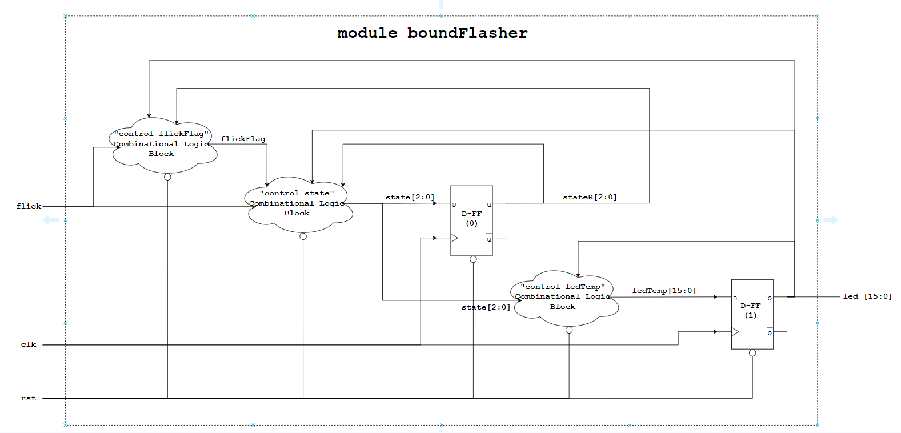

Figure 3.1: Block diagram of Bound Flasher

| | Block | Description | | --- | --- | | D-FF (1) | Synchronize the input signal (ledTemp[15:0]) with the rising edge clock. Using the clock signal to increase or decrease the 16-bit led. The rst (reset) signal is the low-active asynchronous signal (whenever rst == 0, all the led will be off immediately). | | “Control ledTemp”  Combinational Logic block | Using the input signals (state[2:0] and led[15:0]) to control the ledTemp[15:0] signal. | | D-FF (0) | Synchronize the input signal (state[2:0]) with the rising edge clock. Using the clock signal to change the output signal (stateR[2:0]) (stateR means “state Real”). The rst (reset) signal is the low-active asynchronous signal (whenever rst == 0, then the “Real state” will be reset to Initial State immediately). | | “Control state”  Combinational Logic block | If “flick signal” is 1 at “kick-back points”, “state” will be changed to previous “state”; If “flick signal” is 1 at “Initial State”, “state” will be changed to “State 1”. The rst (Reset) signal is the low-active asynchronous signal (whenever rst==0, state will be reset to Initial State immediately). | | “Control flickFlag” Combinational Logic block | Using a flag (called flickFlag) to check if there is a flick signal (flick == 1) at “kick-back points”. If there is a flick signal (flick == 1) at any point of the “kick-back points”, this 1-bit flag will be 1 (flickFlag = 1). The changing of “stateR” signal (state Real) and the led will help to set this flag back to 0. The rst (Reset) signal is the low-active asynchronous signal (whenever rst == 0, flickFlag = 0 immediately). | |
| --- | --- | --- | --- | --- | --- | --- | --- | --- | --- | --- | --- | --- |

Table 3.1: Block diagram of Bound Flasher Description

* 1. State Machine

Figure 3.2: State Machine of Bound Flasher

| Variable name | Description |
| --- | --- |
| reset | Asynchronous signal input. When reset = 0, the state will return to the initial state. |
| flick | When the output (led) is gradually turned OFF (=0) gradually, at LEDs[5] or LEDs[10], if flick = 1, then the lamps will turn OFF gradually again to the **min** lamp of the previous state, except the final state. |
| LEDs | 16 bits output represents 16 lamps. LEDs[0] is the LSB and LEDs[15] is the MSB. |

Table 3.2: Variable name of State machine

| State Name | Description |
| --- | --- |
| INITIAL | All LEDs is OFF (16 bits output = LED[0:15] = 0)  If flick = 1, then state will change to STATE_1. |
| STATE_1 | The LEDs is gradually turned ON from LEDs[0] to LEDs[5], if reset = 0, the state will return to INITIAL. If LEDs[5] is ON, the state will change to STATE_2. |
| STATE_2 | The LEDs is gradually turned OFF from LEDs[5] to LEDs[0], if reset = 0, the state will return to INITIAL.  If LEDs[0] is OFF, the state will return to STATE_3. |
| STATE_3 | The LEDs is gradually turned ON from LEDs[0] to LEDs[10], if reset = 0, the state will return to INITIAL.  If (flick=1 and LEDs[5]=1 (ON)) or (flick=1 and LEDs[10]=1(ON)), all LEDs will gradually turn OFF to min lamp of the STATE_2 (LEDs[0]=0) and the state will return to STATE_2. Else, if LEDs[10] is ON, the state will change to STATE_4. |
| STATE_4 | The LEDs is gradually turned OFF from LEDs[10] to LEDs[5], if reset = 0, the state will return to INITIAL. If LEDs[5] is OFF, the state will return to STATE_5. |
| STATE_5 | The LEDs is gradually turned ON from LEDs[5] to LEDs[15], if reset = 0, the state will return to INITIAL. If (flick=1 and LEDs[5]=1 (ON)) or (flick=1 and LEDs[10]=1(ON)), all LEDs will gradually turn OFF to min lamp of the STATE_4 (LEDs[5]=0) and the state will return to STATE_4. Else, if LEDs[15] is ON, the state will change to FINAL. |
| FINAL | The LEDs is gradually turned OFF from LEDs[15] to LEDs[0]. If LEDs[0] is OFF, the state will change to INITIAL. |

Table 3.3: State name of State machine

# History

| Date | Author | Modified part | Description |
| --- | --- | --- | --- |
| 2022/02/25 | Group 1 | All | New creation |
| 2022/03/05 | Group 1 |  |  |
|  |  |  |  |
|  |  |  |  |